StudyBuddy – A Simple Study Planner Using Python
Mini Project Report
Submitted by:
YASHI BHUSHAN
Registration No: 25BCE10824
Course: CSE1021
Semester: 1
Faculty:
Mr. Sandeep Monga
VIT Bhopal University

Abstract

This project is a small command-line based Study Planner made using basic Python.
The main reason for creating this project was to have a simple tool that helps me keep track of my subjects, tasks, and the amount of time I spend studying.

The program works completely in the terminal and does not require any advanced libraries. All the data is saved in a JSON file, which makes the project very lightweight and easy to understand, even for beginners.

The study planner allows the user to add subjects, manage tasks, record study sessions, view weekly reports, and also get suggestions on which subject needs more attention based on study time.

Overall, the project helped me practice Python concepts like file handling, functions, dictionaries, lists, and basic data storage.

Introduction

Managing studies, tasks, and time can become a little confusing, especially when multiple subjects are involved.
I wanted a simple tool that can run on any computer and doesn’t require internet or complicated setups.

So I created StudyBuddy CLI, a terminal-based study planner that stores everything locally and helps me stay organised.

It is not fancy or advanced, but it is practical and easy to use. It also taught me how real applications store data and manage different functionalities.

Problem Statement
Students often struggle to maintain a consistent study routine and tend to forget tasks or due dates.
There is also a problem of not knowing which subject needs more attention.

Problem:
“How to create a simple tool that helps track study tasks, subjects, and study time in an easy way without requiring complex software?”

Objectives
The main objectives of the project are:
• To build a simple terminal-based study planner.
• To allow users to add and view subjects.
• To let the user create study tasks with due dates.
• To mark tasks as completed.
• To record study sessions in a very easy way.
• To generate a weekly report.
• To suggest which subject needs more attention.
• To store everything in a JSON file for future use.

Existing System

Students usually depend on notebooks, phone reminders, or apps.
Most study apps are complicated or require a login.

The existing methods don’t always give a personalised or simple experience.

Proposed System

The proposed system is a simple, offline, text-based study planner.
No internet needed, no account creation, nothing complicated.

It:
• Stores everything on your computer
• Runs through simple options
• Saves automatically
• Uses very basic Python code that beginners can understand

Software Requirements
• Python 3
• Terminal or Command Prompt
• Any text editor (VS Code, Notepad, etc.)
• JSON file for data storage (auto-created)

Hardware Requirements
• Laptop or PC
• Minimum 2GB RAM
• Any OS: Windows, Mac, or Linux

SDLC Model Used – Waterfall

I followed a mix of the Waterfall approach because the project is small.
The steps were:

1. Requirement Analysis

I planned what features I wanted: add subjects, tasks, study sessions, etc.

2. Design

I decided to create separate .py files for each function (subjects, tasks, storage, etc.) so the project remains organized.

3. Implementation

I wrote the Python code file by file, testing each part.

4. Testing

I ran all features one by one: adding tasks, marking them done, storing sessions, etc.

5. Maintenance

If something breaks or I want to improve it later, I can update it easily.

System Design & Architecture

The program has 8 Python files.
Each file handles only one responsibility.

Architecture :
main.py
- subjects.py → handles adding & showing subjects
- tasks.py → handles tasks (add, view, done)
- study_sessions.py → records study time
- suggestions.py → study suggestions
- reports.py → weekly report
- storage.py → loads/saves JSON data
- utils.py → menu helper

UML Diagrams
- Use Case Diagram
USER
GET SUGGESTION
VIEW REPORT
START STUDY SESSION
MARK TASK DONE
VIEW TASKS
ADD TASK
VIEW SUBJECTS
ADD SUBJECT

- Class diagram
Storage
load_data()
save_data()
Subjects
add_subjects()
show_subjects()

add_task()
list_task()
finish_task()

Tasks

Start_session()
StudySessions

get_suggestion()
Suggestions

Weekly_report()
Reports
Algorithm
1. Start the program.
2. Load the existing data from the JSON file.
If the file does not exist, create a new empty structure
with subjects, tasks, and sessions.
3. Display the main menu with the following choices:
1. Add Subject
2. View Subjects
3. Add Task
4. View Tasks
5. Mark Task as Done
6. Start Study Session
7. Weekly Report
8. Get Suggestion
9. Exit
4. Ask the user to enter a choice.
5. Based on the user input:
a. If the user selects “Add Subject”:
- Ask for the subject name.
- Add it to the list of subjects.
- Save the updated data to the JSON file.
b. If “View Subjects”:
- Read the subjects from the JSON data.
- Display them on the screen.
c. If “Add Task”:
- Ask for task title, subject name, and due date.
- Create a task entry and store it.
- Save the updated data.
d. If “View Tasks”:
- Read all tasks.
- Display each task with subject, due date and status.
e. If “Mark Task as Done”:
- Show all tasks with numbers.
- Ask the user to select task number.
- Change that task’s “done” status to true.
- Save the changes.
f. If “Start Study Session”:
- Ask for the subject studied.
- Wait for the user to press ENTER to end the session.
- Calculate a simple duration (approx/min).
- Store the session details.
- Save the data.
g. If “Weekly Report”:
- Read all study sessions.
- Add up minutes for each subject.
- Display a subject-wise summary.
h. If “Get Suggestion”:
- Check which subject has the lowest study time.
- Suggest that subject to the user.
i. If “Exit”:
- Stop the program.
j. If user enters an invalid number:
- Show an error message.
- Return to the main menu.
6. Repeat the menu after each action until the user chooses “Exit”.
7. End the program.

Implementation
I implemented the project using simple Python functions in separate modules. The data is stored in a JSON file, and the user interacts through menu-driven input. Each module handles a different part to keep the code organized.

Screenshot of how program runs
1) Add Subject
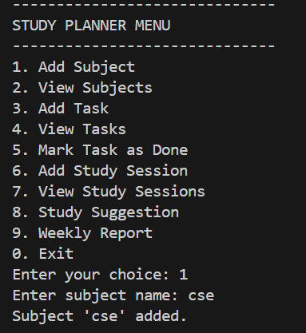
2) View subject
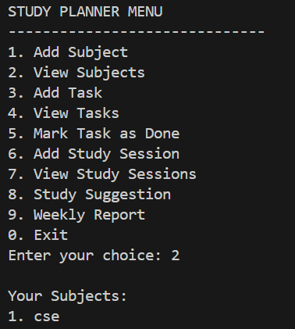
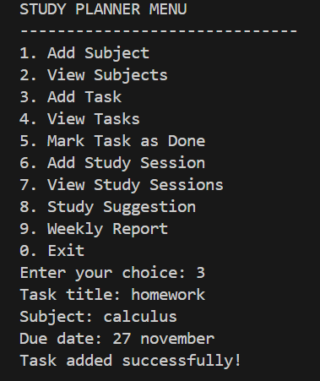
3) Add Tasks
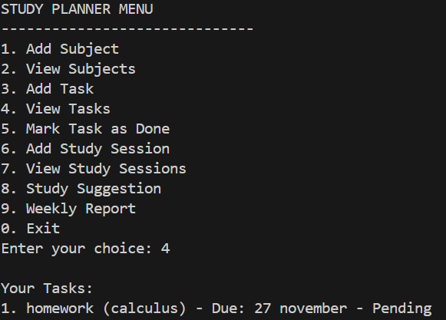
4) View Tasks
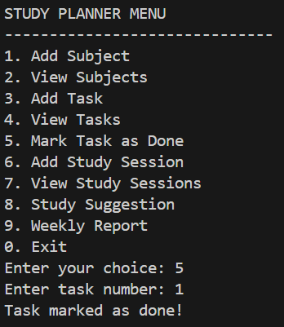
5) Mark task as done
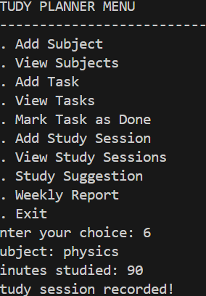
6) Add Study Session
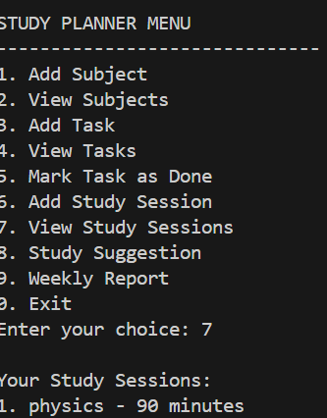
7) View Study Sessions
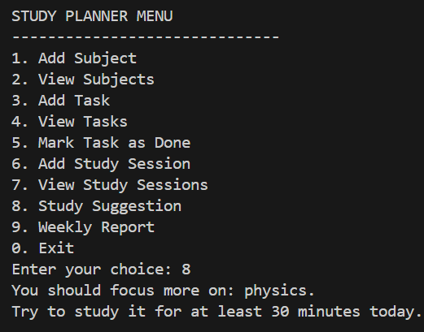
8) Study Suggestion
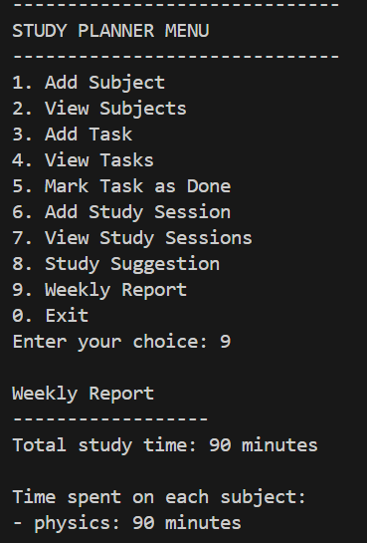
9) Weekly Report
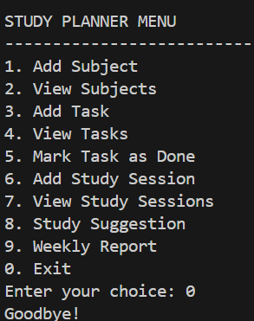
10) Exit

Testing

I tested:
• Adding subjects
• Adding tasks
• Marking tasks done
• Starting a fake study session
• Viewing weekly reports
• Viewing suggestions

Everything works correctly based on basic inputs.

Future Scope
• Real timer instead of fake minutes
• Sorting tasks by date
• Colored output
• User login system
• GUI version with Tkinter
• Export report to PDF
• Notifications or reminders

Conclusion

This was a simple project but it helped me revise Python basics like functions, lists, dictionaries, file handling, and modular programming.
The study planner is easy to use and actually helpful for organizing daily studies.
I kept the code simple so it remains readable and can be improved later.

References
• Python Official Documentation
• Class notes
• Basic JSON tutorials

